Sleep Monitoring System

Sachin Singh
Department of Computer Science & Engineering (Software Engineering)
JAIN (Deemed-to-be University) Bengaluru, India
20btrcs170@jainuniversity.ac.in
Manish Yadav
Department of Computer Science & Engineering (Software Engineering)
JAIN (Deemed-to-be University) Bengaluru, India
20btrco037@jainuniversity.ac.in
Aayushma Thapa
Department of Computer Science & Engineering (Software Engineering)
JAIN (Deemed-to-be University) Bengaluru, India
20btrse072@jainuniversity.ac.in

Priyanka Kumari
Department of Computer Science & Engineering (Internet Of Things)
JAIN (Deemed-to-be University) Bengaluru, India
20btrc072@jainuniversity.ac.in
Preeti Kurmi
Department of Computer Science & Engineering (Internet Of Things)
JAIN (Deemed-to-be University) Bengaluru, India
20btrco071@jainuniversity.ac.in
Prof. Santosh S
Department of Computer Science & Engineering (Software Engineering)
JAIN (Deemed-to-be University) Bengaluru, India
s.santosh@jainuniversity.ac.in

Abstract— Sleep is a crucial aspect of overall health and well-being, and many people struggle to get enough high-quality sleep. To help individuals improve their sleep quality, we propose a sleep monitoring system that uses a smartwatch and machine learning algorithms. This system collects data on sleep duration, sleep quality, heart rate, and other physiological factors, which are analyzed using machine learning algorithms to provide personalized insights and recommendations for improving sleep. These recommendations could include adjustments to sleep schedules, changes to sleep hygiene practices, or dietary changes that can improve sleep. By providing personalized recommendations tailored to each individual's unique sleep patterns and physiological factors, this system has the potential to be a powerful tool for improving sleep quality and overall health. With the increasing popularity of wearable technology and the growing demand for personalized health solutions, a sleep monitoring system that uses a smartwatch and machine learning algorithms could be a valuable tool for individuals looking to improve their sleep quality and overall well-being.
Keywords— User, system, Data, Sleep, Sensor, microcontroller, physical movement, stress, nap

Introduction
Our daily routines cannot be complete without sleep, and having enough good sleep is key to maintaining our general health and wellbeing. Obesity, diabetes, cardiovascular disease, and depression are just a few of the health problems that are linked to poor sleep quality. Unfortunately, many people struggle to get enough quality sleep, and in recent years, this problem has become more prevalent due to increased use of technology, work-related stress, and other factors.
To help individuals improve their sleep quality, we propose a sleep monitoring system that utilizes a smartwatch and machine learning algorithms. This system collects data on sleep duration, sleep quality, heart rate, and other physiological factors, which are analyzed by machine learning algorithms to identify patterns and correlations between different factors and sleep quality.
The proposed sleep monitoring system is designed to be user-friendly and non-intrusive. Users simply wear the smartwatch while sleeping, and the system collects data on their sleep patterns throughout the night. The collected data is then analyzed by machine learning algorithms to provide personalized insights and recommendations for improving sleep quality.
The system can provide recommendations based on several factors, including adjustments to sleep schedules, changes to sleep hygiene practices, or dietary changes that can improve sleep. For example, the system might recommend adjusting the user's bedtime or wake-up time based on their sleep patterns. It could also suggest implementing a consistent bedtime routine, such as avoiding electronic devices before bed or practicing relaxation techniques. The system could additionally recommend changes in diet that can enhance sleep quality, including avoiding coffee and alcohol before bed or eating more foods high in magnesium and tryptophan. The proposed sleep monitoring system has several potential benefits. First, it provides personalized recommendations tailored to each individual's unique sleep patterns and physiological factors. This is particularly important since sleep quality is affected by various factors, including age, gender, and medical history. By providing personalized recommendations, the system can be more effective in improving sleep quality compared to general sleep recommendations.
Second, The system is user-friendly and non-intrusive. Users can simply wear the smartwatch while sleeping, and the system does not require any active participation from the user. This ease of use can increase compliance and adoption rates.
Third, the system utilizes machine learning algorithms to analyze sleep data and provide personalized recommendations. This allows the system to identify complex patterns and correlations between different factors and sleep quality that may be difficult for humans to recognize. Additionally, the system can learn and improve over time as it collects more data, increasing its effectiveness in providing personalized recommendations.
An effective tool for people wishing to enhance their sleep quality and general wellbeing is a sleep monitoring system that makes use of a smartwatch and machine learning algorithms. The suggested sleep monitoring system can help people attain better sleep quality and enhance their general health and well-being in light of the rising prevalence of sleep-related problems and the growing need for personalized health solutions.

Problem definition
A serious health problem that a sizable portion of the population faces is inadequate sleep. Obesity, diabetes, hypertension, melancholy, and anxiety are just a few of the physical and mental health issues that can result from getting too little sleep. Many people find it difficult to comprehend their sleep patterns and implement significant changes to enhance their sleep. People can track their sleep and receive individualized recommendations for improvement with the use of a sleep monitoring system that uses a smartwatch and machine learning.
The answer is to create a sleep monitoring system that employs a smartwatch to gather information about a user's sleep patterns and machine learning algorithms to analyze the information and offer individualized insights and suggestions. The system will monitor a number of sleep metrics, including REM sleep, sleep length, and quality, and utilize this information to produce a sleep score. Once the sleep score has been analyzed, the system will give users information about their sleeping habits, including when they are most likely to wake up, how often they wake up during the night, and how much deep and REM sleep they are obtaining. The system would offer the user personalized suggestions for enhancing their sleep based on this data, such as altering their sleep routine, boosting.

Objective

To aid the user learn more about their own sleep patterns in order to enhance daytime efficiency, improve sleep quality, or address sleep issues including sleep disorders.

To reduce the chances of Insomnia and to have a proper sleep.

To develop a mobile application to help sleeping disorder patients, insomnia patients by keeping track of their sleeping cycles and seek for emergency help with ease.

Here, after developing mobile application, we keep all the records of data in this application and help the patients to overcome from this problem.

To upgrade the monitoring system, it will detect the time of sleeping, posture of sleeping and our sleep quality.

This system is mainly applicable for the people who are suffering from stroke, heart disease, and so on which will impact their quality of sleep.

The system will monitor the sleeping activity of a person and will provide the feedback based on data analyzed by the mobile application using machine learning that will help person in improving quality of sleep.

methodology
When a person is sleeping, their hand is connected to a wearable smartwatch called a Sleep Monitoring Device. Our body temperature and blood pressure drop as we sleep as the physiological demands are reduced. The majority of our physiological functions, such as heart rate, breathing, and brain wave activity, are very predictable during non-REM sleep but fairly changeable when we are awake or during REM sleep. Periodically throughout the night, REM sleep occurs, which is characterized by rapid eye movement, increased bodily activity while dreaming, a faster heartbeat, and shallower breathing. Non-REM sleep is a relaxed state of sleep characterized by low levels of autonomic physiological activity, delta wave brain activity, and dreaming. It always happens during a typical sleep cycle.
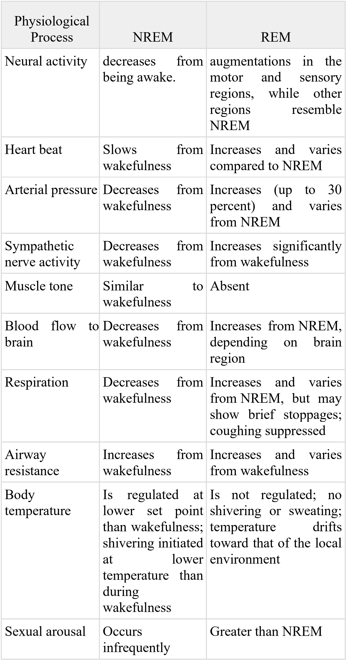
So with the help of sleep monitoring device, we are going to measure different aspect of REM sleep.

Hardware and software used
Sleep monitoring devices uses market available smartwatches that contain different sensors such as optical heart rate sensor, accelerometer sensor, gyroscope, ambient light sensor and microcontroller. Also, we uses a mobile application for storing and processing the sensor data, which is then used to create a sleep plan and analyze the data using machine learning. The hardware component and the mobile application make up the entirety of the system

Hardware
In hardware, we deploy an ambient light sensor, microcontroller, accelerometer sensor, gyroscope, and optical heart rate sensor.
- Optical heart rate sensor
An optical heart rate sensor measures heart waves, which are variations in a blood vessel's volume brought on by the heart pumping blood.
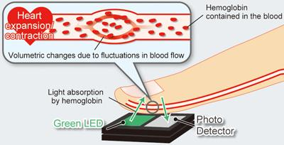
Fig. 1.1 Optical Heart Rate Sensor
Optical heart-rate monitors, which can be integrated into a wrist-worn device, an arm band, or a chest patch, can accurately detect heart rate by examining the arterial pulse of the underlying skin vascular beds. An optical heart rate sensor measures pulse waves, which change a blood vessel's volume as the heart pumps blood. To detect pulse waves, the volume change is measured with an optical sensor and a green LED. Heart rate sensors have been shown to provide accurate readings regardless of the user's age. Only a few of its unique benefits include high sensitivity, electromagnetic interference tolerance, compactness, light weight, adaptability, and the capacity to perform multiplexed or dispersed sensing.

- Accelerometer sensor
An instrument that monitors the acceleration of any person or object in its immediate rest frame is an accelerometer sensor. Acceleration, or the change in speed (velocity) per unit of time, is measured using accelerometer sensors, which are integrated circuits.
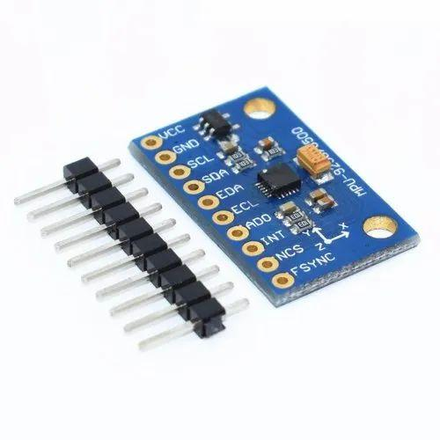
Fig. 1.2 Accelerometer Sensor
Accelerometer sensors are used in a variety of ways by a large number of electronic items, smartphones, wearable technologies, and other applications. Accelerometers can detect vibration on machinery, machinery parts, buildings, process control systems, and safety installations. They can be used to measure tilt, machine vibration, dynamic distance, and speed with or without the influence of gravity in addition to seismic activity.
Most sleeping devices use accelerometer sensors. This sensor is used to evaluate a patient's level of sleep-related movement. Here, our goals are to create and assess a heuristic algorithm for detecting sleep from accelerometer raw data and to compare sleep parameters with sleep diary entries accessed in daily life by adults and older adults.

- Gyroscope
A gyroscope is a tool for determining or maintaining orientation and angular velocity. It typically comprises of a rotating wheel or rotor that is positioned on an axis and can freely rotate in any direction. The rotor resists changes in the axis of its spin because it retains its orientation in space. Gyroscopes are utilized in many different fields, such as robotics, navigation systems, aerospace engineering, and the stabilization of cameras and drones. They also offer motion detecting capabilities in commonplace items like smartphones and game controllers.
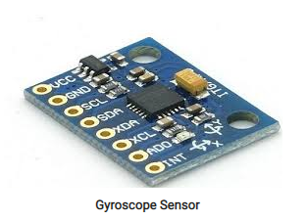
Fig. 1.3 Gyroscope
The gyroscope can detect minute changes in orientation brought on by breathing and heart rate during sleep, as well as more obvious movements like turning over or changing postures. The wearer's sleep length, sleep stages, and sleep quality can all be determined by examining these motions and changes over time using the smartwatch. The wearer's motions may be tracked by the gyroscope, which can also identify if they are in deep sleep, light sleep, or REM (rapid eye movement) sleep. Additionally, it has the ability to identify sleep disruptions including awakenings and snoring.

- Ambient Light Sensor
An ambient light sensor is a type of sensor commonly found in electronic devices such as smartphones, laptops, and smartwatches. It measures the amount of light in the environment and adjusts the device's display brightness accordingly. The ambient light sensor monitors the amount of light hitting a tiny photodiode or phototransistor in order to function. The sensor then sends a signal to the device's software, which adjusts the brightness of the display to a level appropriate for the ambient lighting conditions.
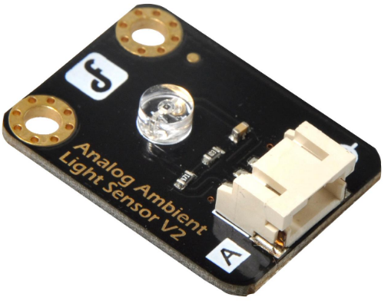
Fig. 1.4 Ambient Light Sensor
Ambient light sensors can also be used in sleep monitoring by detecting changes in the lighting conditions in a room. By measuring the amount of light in the environment, a sleep tracker or smartwatch can determine when the wearer has gone to bed and when they wake up. For example, when the wearer turns off the lights and goes to bed, the ambient light sensor can detect the drop in light levels and trigger the start of the sleep tracking. Similarly, when the wearer wakes up and turns on the lights, the sensor can detect the increase in light levels and trigger the end of the sleep tracking. In addition to tracking sleep duration, the ambient light sensor can also provide insights into the quality of sleep. For example, if the sensor detects changes in the light levels during the night, such as from a passing car or streetlight, it may indicate that the wearer had a restless night and was disturbed by external factors.
- Microcontroller
Depending on the individual watch brand and model, a smartwatch's microprocessor can change. The ARM Cortex-M series and the STMicroelectronics STM32 series are two prominent microcontrollers found in smartwatches. A bespoke Apple S7 processor built on the ARM Cortex-M architecture, for instance, is used in the Apple Watch Series 7's SiP (System in Package). Similar to this, Samsung Electronics' Exynos W920, a CPU designed exclusively for wearables and based on the ARM Cortex-M architecture, powers the Samsung Galaxy Watch 4. Various microcontrollers may be used by other smartwatches, depending on their individual needs and design factors. The final decision on the microcontroller will be based on elements like the needed performance, power consumption, and price.
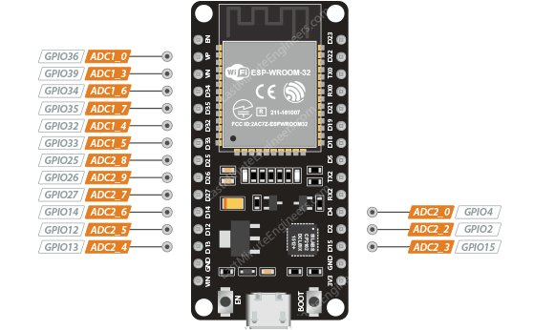
Fig.1.5 ESP 32 Microcontroller
In smartwatches that measure sleep, the microcontroller is crucial since it is in charge of gathering and processing data from the numerous sensors that are used to do so. The accelerometer, heart rate monitor, gyroscope, and ambient light sensor normally provide data to the microcontroller, which employs algorithms to analyze the data and determine the wearer's level of sleep and when they are asleep. Additionally, the microcontroller has the ability to save this information and transmit it to the user through a mobile app. The microprocessor in a smartwatch can monitor vital indications like heart rate and blood oxygen levels in addition to tracking sleep. It can also display the time and other notifications, track physical activity, and track other notifications.

Mobile Application
A tiny Android app that displays a patient's current sleep quality status has also been created. This app makes it easier to see the patient's sleep quality. It will be simple to determine the patient's general sleep condition thanks to calculated findings that the app may retrieve and display in a pie chart. Figure displays a screenshot of the application.
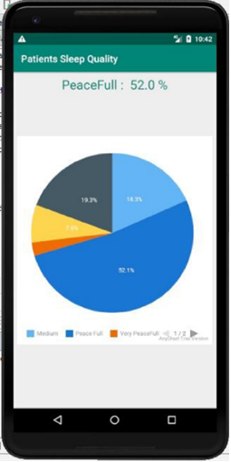
Fig 1.6 Mobile Application Screen Shot
Figure shows a pie graph of the patient's sleep data that shows how the patient's sleep data is broken down into five categories. The graph showed that the patient slept soundly. Blue is used in this graph to represent sound sleep.

Litrature survey
The sleeping disorder refers to when the user is unable to sleep their normal hours which build up stress and have subsequent drastic effects on user’s health. Some of the drastic effects of the sleeping disorders are depression and in major case the sleeping disorder sometimes led to unconditional heart which makes it quite vital and important for the user to have subsequent hours of sleep. In the busy and hectic world, it’s quite normal to get stressed but the nap in between the work enables better mind freshness and subsequently provides enhanced work focus. Several inventions have been developed which allows the user to get themselves relaxed at the workplace.
The authors of the article "Sleep Monitoring Systems: Current Status and Future Challenges" call attention to the accuracy and practicality issues with current monitoring methods like actigraphy and polysomnography. Comparing the results of several research can be difficult due to the disparity in various sleep monitoring technology. The collection and use of sleep data raise ethical concerns regarding privacy and data security. The paper makes some recommendations for potential remedies to the problems with sleep monitoring, including the development of new monitoring technologies, the standardization of measurement techniques, increased collaboration between experts in various fields, and more research into the relationship between sleep and health. [1]
The article "A Real-Time Sleep Monitoring System with a Smartphone" describes a real-time sleep monitoring system that uses a smartphone's sensors and machine learning algorithms to track sleep patterns and stages. The system aims to address the shortcomings of existing sleep monitoring technology by providing a more workable and accessible solution. The study describes the challenges involved in developing a reliable and accurate sleep monitoring system, as well as the approach taken to overcome these challenges. The suggested approach was employed by a small test group of subjects, and the findings showed that it functioned brilliantly in identifying sleep stages and metrics linked to sleep quality. [2]
This study conducts a literature review of the "Internet of Things for Sleep Quality Monitoring System: A Survey" study, which uses the Internet of Things (IoT) to monitor sleep quality. The goal of the study is to outline the present trends, issues, and potential directions for further research in this area. The study discusses a range of subjects including sensor technology, data analytics, privacy and security concerns, and IoT-based sleep quality monitoring. The project intends to identify potential areas for IoT-based sleep monitoring research in the future and to provide insights into the challenges and potential of such systems. The authors proposed combining many sensors with data analytics techniques to improve the precision and. [3]
The study's main objective, as stated in the publication "Development of a sleep monitoring system with wearable vital sensor for home use," is to create a wearable home sleep monitoring system. The key issue raised by the study is the lack of a dependable, reasonably priced sleep monitoring device that can be used at home to enhance sleep quality and identify sleep disorders. The suggested system evaluates the data to determine sleep disorders and evaluate sleep quality. It accomplishes this by using a wearable sensor to measure vital signs including heart rate, respiration rate, and physical movement. The study also looks at the challenges in creating a wearable sleep monitoring system and suggests solutions. [4]
The paper "Nonconstrained Sleep Monitoring System and Algorithms Using Air-Mattress with Balancing Tube Method" uses an air-mattress with a balancing tube method to provide a non-invasive way to monitor sleep patterns. The system uses non-invasive sensors and advanced algorithms to gather and interpret data on a variety of variables, such as heart rate, breathing rate, body movements, and sleep stages. The system is a reliable and effective tool for tracking sleep since it provides informative data on sleep quality and probable sleep issues. The study conducted to evaluate the accuracy of the system shows great accuracy in identifying sleep stages when compared to polysomnography (PSG), which is recognized as the gold standard for sleep monitoring.[5]
The development of a passive, ballistocardiography-based sleep monitoring system that can track heart rate and breathing rate while a person sleep is described in the study "Development and Preliminary Validation of Heart Rate and Breathing Rate Detection Using a Passive, Ballistocardiography-Based Sleep Monitoring System". The technology uses a pressure-sensitive pad under the mattress to detect ballistocardiographic (BCG) signals, which are generated by your body's motions while you sleep. The processing of the BCG signals by sophisticated algorithms yields information on the user's sleep patterns by detecting heart rate and breathing rate. The study that was utilised to verify the accuracy of the system shows that it has a high accuracy in detecting heart rate and breathing rate when compared to polysomnography (PSG), making it a trustworthy and effective tool for sleep monitoring.[7]
The article "Long-term Sleep Monitoring System and Long-term Sleep Parameters using Unconstrained Method" by Jeyhun Shin, Young Joon Chee, and Kiangsu Park describes a long-term sleep monitoring system that can measure sleep parameters using an unconstrained method. It demonstrates a long-term sleep monitoring system that measures several aspects of sleep using an unrestricted technique. The system utilizes a bed-based sensor system that can detect body movements, respiratory signals, and heart rate to calculate sleep stages, sleep efficiency, and other sleep parameters. The study shows that the system can accurately measure sleep parameters over long periods of time, making it a valuable tool for monitoring sleep disorders and evaluating the effectiveness of treatments. Overall, the system provides valuable insights into sleep patterns and potential sleep disorders while maintaining user comfort and ease of use.[8]
The paper "Validation of Sleep-Tracking Technology Compared with Polysomnography in Adolescents" by Massimiliano de Zambotti, Fiona C. Baker, and Ian M. Colrain presents a study comparing the precision of sleep-tracking technology with polysomnography in teens. This study compared the Fitbit Charge HR sleep tracker's accuracy to that of teen polysomnography to see which was more reliable. The 25 participants in the study found that the Fitbit considerably overestimated overall sleep time, sleep start latency, and awakening after sleep initiation when compared to polysomnography. The study argues that more research is necessary to improve the devices' accuracy and stresses the importance of using caution while using sleep-tracking technology for clinical or research purposes. In conclusion, the article offers insightful information about the limitations of sleep monitoring technologies and [9]
Zilu Liang and Bernd Plunderer’s paper "Sleep tracking in the real world: a qualitative study into barriers for improving sleep" gives a qualitative study on the challenges associated with using sleep-tracking technology to improve sleep. The article offers a qualitative investigation of the challenges to using sleep-tracking technologies to improve sleep. The study involved 12 participants who used a sleep-tracking device, and the results showed that accuracy and reliability of the device were significant concerns for the participants. Additionally, participants reported that the sleep data provided by the devices did not necessarily lead to changes in behavior or better sleep quality. The paper highlights the importance of considering user experience and motivation when designing sleep-tracking technology and the need for further research to improve the usability and effectiveness of such devices. [10]
The paper "Pajama’s, Polysomnography and Professional Athletes: The Role of Sleep Tracking Technology in Sport" by Driller et al. discusses the use of sleep tracking technology in professional athletes. The paper presents a case study of a professional rugby team that used sleep tracking devices to monitor their sleep and optimize their recovery. The study found that sleep tracking technology can provide valuable information for athletes and coaches to identify and address sleep-related issues, which can improve performance and reduce the risk of injury. The paper also highlights the challenges of using sleep tracking technology in a sports context, such as the need for reliable and accurate data and the importance of privacy and data protection. Overall, the paper provides insights into the potential benefits and challenges of using sleep tracking technology in professional sports. [11]
The study "How Does Sleep Tracking Influence Your Life?" by Koosharem et al. explores how people's behavior and perceptions of sleep are affected by sleep monitoring technologies. Twenty people participated in the study, each of whom utilized a sleep tracking device and answered questionnaires and interviews. The findings demonstrated that the use of sleep tracking equipment improved participants' awareness of and comprehension of their sleep patterns, resulting in modifications to sleep behavior and routines. However, the study also revealed concerns around data privacy, accuracy of the devices, and the potential for sleep tracking technology to create stress and anxiety around sleep. Overall, the paper highlights the potential benefits and drawbacks of sleep tracking technology, emphasizing the need for further research and design improvements to maximize the positive impact of such devices. [12]
The study "The Design and Realization of Sleep-monitoring System Based on Body-movement Signals" by Wei et al. suggests a non-invasive sleep monitoring system that uses body movement signals to track sleep patterns. The technology uses a microcontroller and an accelerometer to gather and analyze data on your sleeping body movement. The authors propose a sleep stage classification algorithm based on the Fast Fourier Transform (FFT) and linear discriminant analysis (LDA) techniques to analyze movement data and classify sleep stages. The system was tested on five healthy persons, and the results showed that it could reasonably categorize different stages of sleep. The proposed system provides a non-invasive, low-cost alternative to current sleep monitoring techniques, which may be useful for applications using home-based sleep monitoring. [13]
The paper "High-Performance and Resource-Efficient IoT-based Sleep Monitoring System" describes a high-performance and resource-efficient IoT-based sleep monitoring system. The device collects body movement information and snoring sounds using an accelerometer and a microphone, respectively, and sends the information to a cloud server for analysis. The suggested method is built to ensure precise sleep tracking while minimizing power usage and data transmission. The experimental results show the system's efficiency in accurately identifying sleep stages and sleep-related events, pointing to its potential for use in real-world sleep monitoring and management. [14]
An inconspicuous sleep monitoring system based on a bed sensor for collecting sleep-related body movements and a smartphone application for gathering self-reported sleep data is described in the paper "An unobtrusive sleep monitoring system for the understanding of human sleep behavior." The suggested method aims to pinpoint sleep issues and provide a precise and thorough analysis of sleep behavior, including sleep onset, duration, effectiveness, and quality. Ten healthy individuals were used in a pilot study to evaluate the system, and the results showed that the system can provide important information for sleep monitoring and management as well as the potential to be used for the identification and treatment of sleep disorders. [15]
An inconspicuous sleep tracking system grounded on a bed sensor for collecting sleep-related body movements and a smartphone application for gathering self-reported sleep data is described in the paper "An unobtrusive sleep monitoring system for the understanding of human sleep behavior." The suggested method aims to pinpoint sleep issues and provide a precise and thorough analysis of sleep behavior, including sleep onset, duration, effectiveness, and quality. According to plot research using 10 healthy people to test the system, the system can give pertinent data for sleep monitoring and management, and it has the potential to be utilized for the diagnosis and treatment of sleep issues. [16]
A literature review is published in "A survey on sleep assessment methods" by Vanessa Ibanez, Joseph Silva, and Omar Cauli with the goal of summarizing and contrasting the most recent sleep evaluation techniques. They discovered that, in terms of correctness, sleep monitoring techniques can be categorized as follows after analyzing all of the current sleep evaluation techniques: Questionnaire Contactless devices, contact devices, contact devices, and polysomnography. According to a survey of the literature, current subjective approaches have a sensitivity range of 73% to 97.7% and a specificity range of 50% to 96%. A sensibility of greater than 90% is presented by objective techniques like actigraphy. One drawback of such technology is that their specificity is low in comparison to their sensitivity. [17]
Different treatments for sleeping difficulties are suggested in "Assistive technology to enable sleep function in patients with acquired brain injury: Issues and opportunities" by Anmol Biajar, Tatyana Mollayeva, Sandra Sokoloff, and Angela Colantonio. They recommended therapies include continuous positive airway pressure (CPAP) therapy, adaptive servo-ventilation, light therapy, positional therapy, cognitive behavioral therapy, and nasotracheal suction mechanical ventilation. These are some common therapies for insomnia in those with brain injury. [18]
The authors of "Non-invasive analysis of sleep patterns via multimodal sensor input" are Vangelis Metis, Dimitris Kotsiopoulos, Vassilis Athetoses, and Fillia Mak. They use Microsoft Kinect and a bed pressure mat sensor to examine people's sleep habits. They gathered information from seven different people by imitating their sleeping patterns. Each person spent some time lying on their bed and carried out the activities they would usually do before going to sleep. Two distinct sensors were used to record the various actions taken during that time. then placed a bed pressure mat underneath the covers for the first one, and then affixed a Microsoft Kinect sensor to the ceiling for the second. The captured information was then manually annotated in accordance with. [19]
The paper "Validation of a Consumer Sleep Wearable Device with Actigraphy and Polysomnography in Adolescents Across Sleep Opportunity Manipulations" by Xuan Kai Lee et al. sought to validate a consumer sleep wearable device for monitoring sleep stages and parameters in adolescents using polysomnography (PSG) as the gold standard. The research found that while the consumer device had lower sensitivity for identifying different stages of sleep, it was precise for measuring total sleep time, sleep start latency, and wakefulness following sleep onset. Although the gadget is useful for monitoring adolescent sleep, the scientists advise against utilizing just its results for clinical diagnoses. [20]
By using polysomnography (PSG) as the gold standard, Xuan Kai Lee et al.'s paper "Validation of a Consumer Sleep Wearable Device with Actigraphy and Polysomnography in Adolescents Across Sleep Opportunity Manipulations" sought to validate a consumer sleep wearable device for monitoring sleep stages and parameters in adolescents. According to the study, although the consumer device was less sensitive to different sleep stages, it was accurate at detecting total sleep time, sleep start latency, and wakefulness after sleep initiation. The scientists caution against utilizing the device's results by itself to make clinical diagnoses, despite the fact that it is useful for monitoring adolescent sleep. [21]
A system, method, and item for stress reduction and sleep promotion are disclosed in U.S. Pat. No. 11013883B2, which was created by Todd Youngblood and Tara Youngblood of Mooresville, North Carolina (US). A system for reducing stress and promoting sleep includes at least one remote control and a piece of equipment for regulating surface temperature. Some implementations include a pulsed electromagnetic frequency device, at least one remote server, and/or at least one body sensor in their system for enhancing sleep and lowering stress. [22]

A bed with a mattress and a foot warming system is described in U.S. Patent No. 20210289947A1 by inventors Ronald Stuarant BENSON of Toronto, California, and Ryan Cameron DENOMME of Kitchener, California. A support structure that is positioned beneath and covered by the mattress cover may also be included in the mattress. A heating unit, an envelope, a power source, and an electrical connector that connects the heating unit to the power source are all possible components of the foot warming system. Between the top and bottom of the enclosure, the heating unit may be positioned inside. At the foot of the bed, between the support framework and the mattress cover, the heating unit and the envelope. [23]

related work
We may divide current research on modern sleep monitoring systems into four areas.
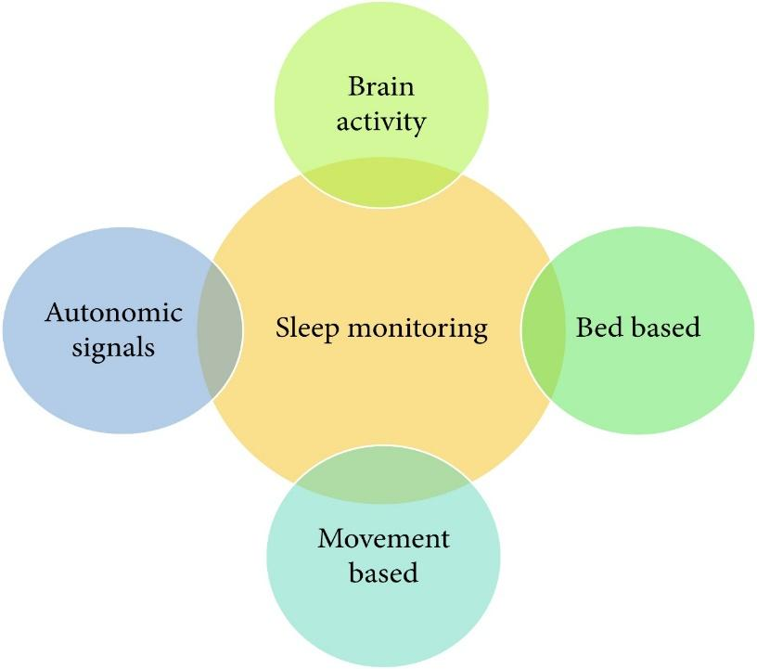
Fig. 2.1 Related work Category

Modern sleep monitoring systems employ several sensor technologies. These sensors can also be used for sleep staging. Different sleep stages are not addressed by the suggested system. Polysomnography (PSG), a form of sleep monitoring method, looks at physiological factors such breathing, body temperature, muscle movement, and oxygen saturation (SPO2). Using this technology, researchers can group the time of sleep onset and wake-up. A device was attached to the patient's wrist to track any changes or physical parameters as he slept. A thorough investigation reveals a direct link between wrist movement and the user's quality of sleep. A passive infrared (PIR) sensor and audio-video recording can also be used to assess the patient's sleep status.
An ambient sleep monitoring technique using in-home sensors is demonstrated in the current study. PIR sensors for motion detection, interaction sensors that are attached to windows and doors, room temperature monitors, and other devices that can detect heat and energy are all included in this study.

existing system
Other tools are also available and are currently used for sleep assessment at home, as shown in Table. The market has a lot of these things for sale. The table below compares various REM (rapid eye movement) and NREM (nonrapid eye movement) sleep monitoring devices.
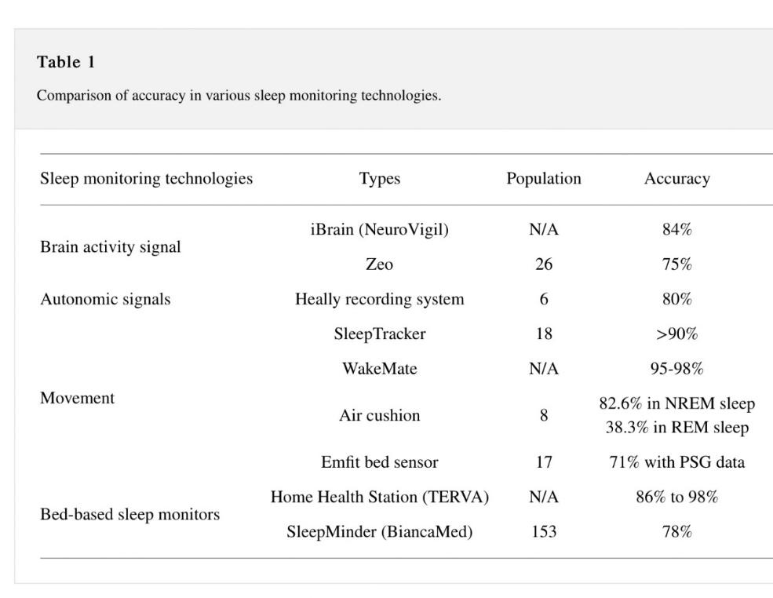
The iBrain includes the helmet, which only records front lead EEG impulses. The Zeo gadget, worn on the forehead, measures electroencephalogram (EEG), electromyography muscle electromyogram (EMG), and electrooculogram (EOG) impulses and communicates the data to a mobile phone through Wi-Fi or Bluetooth. The Heally system calculates the patient's respiratory and cardiac movements using sensors built into a shirt. The SleepTracker is yet another accessory for watches. This wristwatch logs human activity associated with sleep. The patient wears a bracelet around their wrist as part of the WakeMate system. Data from actigraphy is transmitted on this band to a mobile phone. The total amount of time spent sleeping, the frequency with which the patient is awake while sleeping, and information on the "sleep quality" based on physical activity are among the data included in this list. A beanbag with air within is called an air cushion, and it can calculate numerous environmental and physical parameters. Emfit Bed Sensor measures things like breathing rate, heart rate, and body movement using Emfit foil electrodes positioned beneath a mattress.
Modern society frequently uses mobile devices, which also offer a number of apps to track patients' sleep. Heart rate signals, acoustic signals, and accelerometer data are all used in a system known as ubiquitous architecture for sleep monitoring. This concept functions in conjunction with a smartwatch or smartphone-based monitoring system. Additionally, it proposes an original and clever signal organization algorithm.
The aforementioned techniques and technologies are useful for examining patients' sleep, despite this. There are a lot of disadvantages as well. The majority of them lack a foundation in machine learning and the IoT. The now well-known and growing Internet of Things (IoT) idea consists of many sensing devices, data transfer protocols, and cloud computing capabilities. Due to the high energy consumption of gadgets like mobile devices, such models can only be used for a limited time.

Problem of existing system
The existing systems are more focused on providing the assistance to the user in monitoring the sleep and guiding the user to get relaxed while sleeping using various attachments. The inventions are not focused monitors the real time health related parameters of the user while they take nap and does not provide the user with favorable ambient conditions and no means to determine their real time location at the time of nap.
In order to overcome the aforementioned drawbacks, here the proposed device will allow the user to take a nap from busy schedules and prevent the user from getting stressed and monitors the real time health related parameters of the user while they take nap along with locating the user while they are having the nap. It will also recommend the time to take nap based on the busy schedule of a person. It will monitor the sleeping activity and duration of a person and help them to provide information about their sleep activity and will also advise them how they can improve it.

market survey
As we are aware, people sometimes have sleeping disorders, the survey was developed to examine peoples' sleeping habits. We're curious in the conventional methods people use to treat sleeping disorders and how our product might be able to aid them. By analyzing the patient's reactions, we can offer services to lessen the patients' drowsiness and, as a result, advise remedial measures that may result in better-quality sleep.
Survey was created online through goggle forms. We created goggle forms to collect all the information about sleeping disorder or insomnia patients’ problem by questioning them what’s the reason of their insomnia, whether they want any sleeping assessment or not, and if they want What features they expect in the sleep tracking device.
In our survey persons from every age group participated but our main target audience was persons of age group between 18 to 30 years because sleeping problem is mostly seen in this age group person.
Survey Questions
- Do you know about Insomnia?
- Have you ever felt sleeplessness?
- If yes than what measures did you take to overcome it?
- Do you wish a device that will track your sleeping activities and provide you a proper routine for healthy sleep?
- What valuable feature will you suggest to be added in that sleep monitoring system?

Responses
- Do you know about Insomnia?
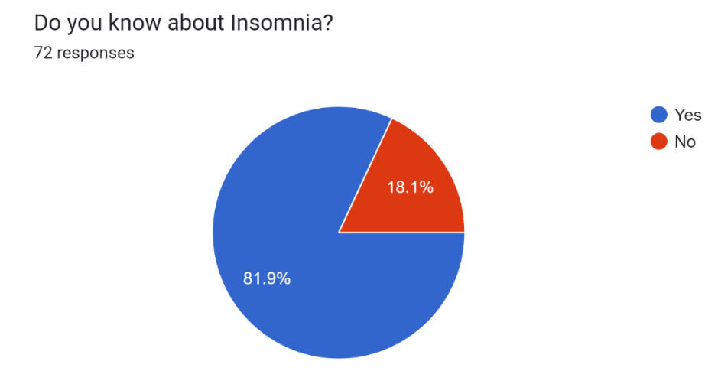
About 82% people from the survey are aware of insomnia as most of them are suffering from this problem. According to the survey insomnia is increasing rapidly and it is seen in adult mostly insomnia is happened due to pressure, overthinking about something and in today’s generation youngster are having so much pressure that’s the reason of their insomnia

- Have you ever felt sleeplessness?
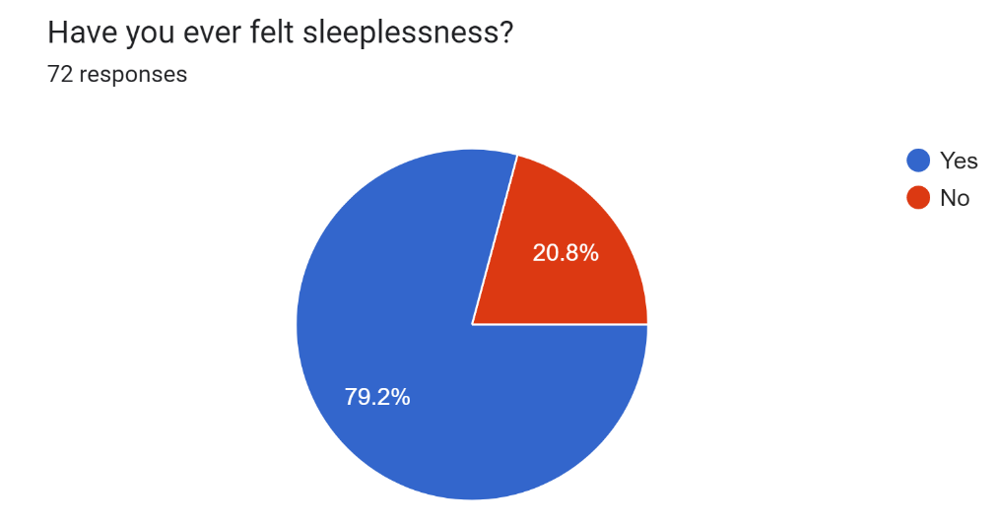
More than 79% of the people are suffering from sleeping disorder. The review of the people indicates that they want proper sleep but due to insomnia, or sleeping disorder they are unable to have proper sleep. As we all know our body requires proper sleep of 7-8 hours in adult.

- If yes than what measures did you take to overcome it?
According to our survey review the people who are suffering from sleeping disorder disease some of them used to listen music to make their mind peace and have proper sleep, some of them take medicines to overcome with this problem, some of them watch movies or series, and some of them do meditation for the peace of mind to sleep properly. So to overcome with this problem they demands for sleeping monitoring system that is system which will detects their sleeping routine for their proper sleep also we will add some new features in it as per their demands.

- Do you wish a device that will track your sleeping activities and provide you a proper routine for healthy sleep?
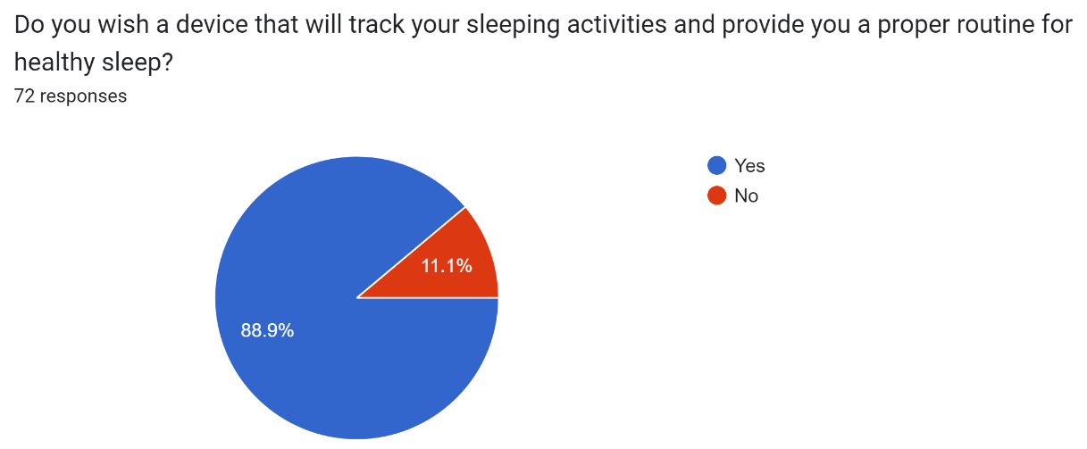
According to our survey majority of people wants to overcome with insomnia so as per their response 89% of them want sleeping device which makes them feel sleepy during night, we got so many positive responses for our sleeping monitoring system.

- What valuable feature will you suggest to be added in that sleep monitoring device?
According to the response of the people they want peaceful tune in the device which makes their mind mediate and silence. Some people want the device must detect the interrupted sleep. some wants alarm clock systems that helps them to wake up at time.

Conclusion of survey
Accordingly, we deduced from the poll that young people tend to have sleeping disorders the most. They are employing tried-and-true techniques to deal with this issue, such as listening to music, reading books, watching films, and practicing meditation. Even if they are aware that the medication is hazardous when used over a long period of time, some people nonetheless take it to treat their sleeping condition. Just by adhering to a basic sleep schedule, this sleeping issue can be healed. Therefore, our device will monitor sleep patterns and deliver a weekly sleep schedule. If it lives up to their expectations, this device could be quite helpful for those in the younger age range. Additionally, we'll add a few of the suggested features for that. The gadget can integrate functions from the mobile app including deep sleep tracking, uninterrupted sleep tracking, and regular alarm system. Most people are suffering from insomnia, depression, and other sleeping disorders, which interfere with their regular sleeping patterns and lead to high demands for the most popular sleep apps, according to a survey of the population. The user-assistive sleeping system is highly helpful for people based on their needs. Some people demand a soothing song to help them go asleep, others require the ability to detect interrupted sleep, and yet others demand a daily alarm to go to bed. Therefore, in response to their request, we chose to design this device so that users may carry it around with them.

proposed system
For overcoming all the limitations of existing system, we are going to propose a personalized sleep analysis algorithm that will not only monitor the sleep activities, but it will also provide feedback, measures and diet suggestion for effective sleep.
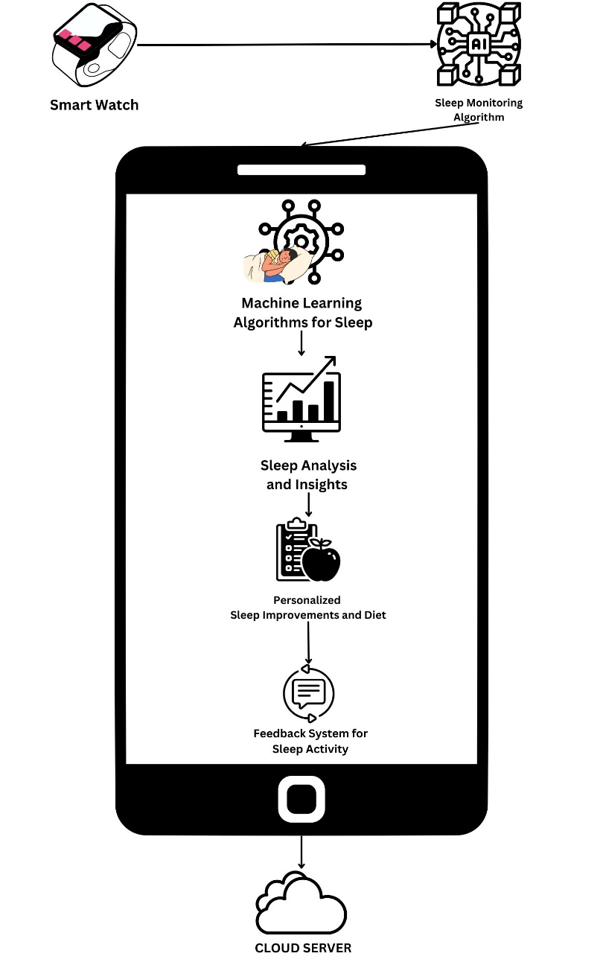
Fig. 3.1 Proposed System
- Smartwatch: This component is responsible for collecting data about the user's sleep, such as sleep duration, sleep quality, and REM sleep. The sensor will be embedded in the smartwatch and will collect data throughout the night.
- Sleep Monitoring Algorithm: This component will collect and process the data collected by the smartwatch sensor, generate a sleep score, and initiate the machine learning algorithms for sleep analysis.
- Machine Learning Algorithms: This component will analyze the sleep score generated by the sleep monitoring algorithm and provide insights and recommendations for sleep improvement.
- Sleep Analysis and Insights: This component will analyze the data collected by the smartwatch sensor and provide insights into the user's sleep patterns, such as when they are most likely to wake up, how often they wake up during the night, and how much deep and REM sleep they are getting.
- Personalized Sleep Improvements and Diet: This component will provide personalized recommendations for improving the user's sleep, as well as recommendations for their diet based on their sleep data. This component will take into account the user's sleep patterns, sleep score, and diet preferences to provide tailored recommendations.
- Feedback System for Sleep Activity: This component will provide feedback on the user's sleep activity, such as whether they are meeting their sleep goals, and suggestions for how they can improve their sleep habits. This component will also provide feedback on their diet, such as whether they are eating a balanced diet that supports good sleep.
- Sleep Data Storage: This component will store the user's sleep data in a secure and reliable database for future analysis and reference

system architecture
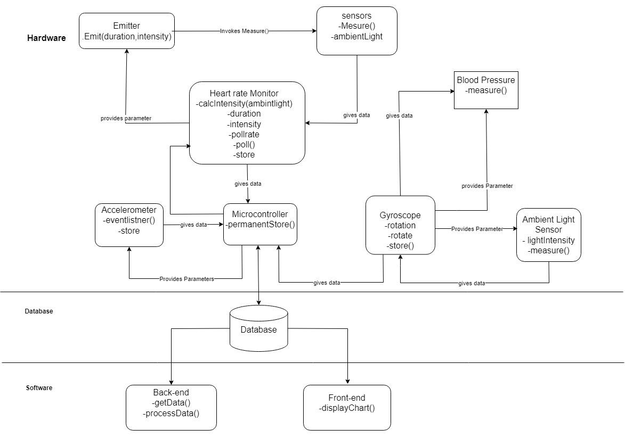
Fig. 3.1 System Architecture
Set of programs plus data plus documentation along with mechanisms, methods and procedures. A system is a set of components that combine together to achieve common goal. It can be comprised of hardware and software. This system design is divided into hardware, database and software.

Hardware

- Microcontroller
Microcontroller is used for collecting and processing data from the various sensors used to track sleep. It receives data from all the other hardware components, processes them and instructs the other component. It is also responsible for sending data to the database.

- Optical Heart rate monitor
It is responsible for measuring the heart rate and storing it. It is divided into two components and they are
- emitter
- sensor
The emitter is responsible for producing light so that the sensor can take the reading. The sensor is responsible for measuring the heart rate as well as the available ambient light. The ambient light data is sent to the Arduino Uno to calculate the required duration and intensity of light so that the sensor can take the reading.

- Accelerometer
It is responsible for detecting any movement of the user during sleep. The measured movement is then sent to the Arduino Uno. The sensitivity is adjusted by the Arduino Uno.

- Gyroscope
Gyroscopes are able to recognize small variations in orientation brought on by breathing and heart rate as well as more obvious movements like turning over or changing postures. The wristwatch can provide information on the wearer's sleep length, sleep stages, and sleep quality by examining these motions and changes over time.

- Ambient Light Sensor
Ambient light sensors can also be used in sleep monitoring by detecting changes in the lighting conditions in a room. By measuring the amount of light in the environment, a sleep tracker or smartwatch can determine when the wearer has gone to bed and when they wake up.

Database:
A microcontroller contacts a web server through HTTP.
- PHP script is run by the web server.
- PHP script interacts with MySQL database after processing data from HTTP Request.
- After processing the outcome, the PHP script sends an HTTP response with the outcome to Arduino
Software:
In terms of software, it makes use of a mobile application with a machine learning algorithm that can recommend ways to enhance sleep.
The first stage would be to compile information on the user's sleeping habits, which can be done with the help of a smartwatch or other wearable gadget that can track sleep. These details could include factors like total hours of sleep, the length of each sleep stage, interruptions in sleep, and heart rate variability.
Following the collection of the data, a machine learning model can be trained to examine the patterns and make recommendations for enhancing sleep. Regression analysis, decision trees, or neural networks are just a few of the methods the model may employ to find connections between the data and particular elements that might have an impact on how well you sleep.
The model could then propose actions the user can take to improve their sleep based on these relationships. For instance, the model might advise the user to cut back on their caffeine intake before bed if it finds a link between poor sleep quality and high caffeine intake. Similar to this, the model can suggest that the user establish a regular bedtime routine or practice soothing tactics before bed if it observes that they frequently wake up in the middle of the night.

Conclusion
In conclusion, a sleep monitoring system that uses a smartwatch and machine learning algorithms can provide users with valuable insights into their sleep patterns and recommendations for improving their sleep quality. By collecting data on sleep duration, sleep quality, and other sleep-related metrics, the system can provide personalized insights into sleep patterns, such as when the user is most likely to wake up and how often they wake up during the night. Machine learning algorithms can then analyze this data and provide tailored recommendations for improving sleep, such as adjusting sleep schedules or changing sleeping positions. Additionally, by including a feedback system that provides suggestions on sleep activity and diet, the system can provide users with a comprehensive set of recommendations for improving their overall health and well-being. For people wishing to enhance their sleep quality and general health, a sleep monitoring system that makes use of a smartwatch and machine learning algorithms has the potential to be an effective tool. With the right design and implementation, such a system can provide users with valuable insights and personalized recommendations, ultimately leading to better sleep and a better quality of life.

References
- Ibáñez V, Silva J, Cauli O. A survey on sleep assessment methods. PeerJ. 2018 May 25;6:e4849. doi: 10.7717/peerj.4849. PMID: 29844990; PMCID: PMC5971842.
- Biajar, Anmol, Tatyana Mollayeva, Sandra Sokoloff, and Angela Colantonio. “Assistive Technology to Enable Sleep Function in Patients with Acquired Brain Injury: Issues and Opportunities.” British Journal of Occupational Therapy 80, no. 4 (April 2017): 225–49. https://doi.org/10.1177/0308022616688017.
- Metsis, V., Kosmopoulos, D., Athitsos, V. et al. Non-invasive analysis of sleep patterns via multimodal sensor input. Pers Ubiquit Comput 18, 19–26 (2014). https://doi.org/10.1007/s00779-012-0623-1
- Lee XK, Chee NIYN, Ong JL, Teo TB, van Rijn E, Lo JC, Chee MWL. Validation of a Consumer Sleep Wearable Device With Actigraphy and Polysomnography in Adolescents Across Sleep Opportunity Manipulations. J Clin Sleep Med. 2019 Sep 15;15(9):1337-1346. doi: 10.5664/jcsm.7932. PMID: 31538605; PMCID: PMC6760396.
- Ronald Stuart BENSON, Ryan Cameron DENOMME. Sleep monitoring system (2018) U.S. Pat. No.10874350B2
- Todd Youngblood, Tara Youngblood Stress reduction and sleep promotion system (2021) U.S. Pat No.11013883B2
- Kody Lee Karschnik, Omid Sayadi, Wade Daniel Palashewski, Ramazan Demirli, Eric Rose, Saurabh Chhaparwal Bed with foot warming system (2020) U.S. Pat No. 20210289947A1.
- PAN, Qiang & Brulin, Damien & Campo, Eric. (2020). Sleep monitoring systems: Current status and future challenges (Preprint). JMIR Biomedical Engineering. 5. 10.2196/20921.
- T. -Y. Han, S. -D. Min and Y. Nam, "A Real-Time Sleep Monitoring System with a Smartphone," 2015 9th International Conference on Innovative Mobile and Internet Services in Ubiquitous Computing, Santa Catarina, Brazil, 2015, pp. 458-461, doi: 10.1109/IMIS.2015.69.
- N. Surantha, G. P. Kusuma and S. M. Isa, "Internet of things for sleep quality monitoring system: A survey," 2016 11th International Conference on Knowledge, Information and Creativity Support Systems (KICSS), Yogyakarta, Indonesia, 2016, pp. 1-6, doi: 10.1109/KICSS.2016.7951426.
- Suzuki, Takuji & Ouchi, Kazushige & Kameyama, Ken-Ichi & Takahashi, Masaya. (2009). Development of a Sleep Monitoring System with Wearable Vital Sensor for Home Use.. 326-331.
- Nonconstrained Sleep Monitoring System and Algorithms Using Air-Mattress With Balancing Tube Method. (2010, January 1). IEEE Journals & Magazine | IEEE Xplore. https://ieeexplore.ieee.org/stamp/stamp.jsp?tp=&arnumber=5290162&tag=1
- Development and Preliminary Validation of Heart Rate and Breathing Rate Detection Using a Passive, Ballistocardiography-Based Sleep Monitoring System David C. Mack, James T. Patrie, Paul M. Suratt, Robin A. Felder, and Majd Alwan, Senior Member, IEEE https://ieeexplore.ieee.org/stamp/stamp.jsp?tp=&arnumber=4663856
- Promises and Challenges in the Use of Consumer-Grade Devices for Sleep Monitoring Sirinthip Roomkham , David Lovell , Joseph Cheung , and Dimitri Perrin. https://ieeexplore.ieee.org/stamp/stamp.jsp?tp=&arnumber=8309286
- Long-term Sleep Monitoring System and Long-term Sleep Parameters using Unconstrained Method Jaehyuk Shin, Youngjoon Chee, and Kwangsuk Park, Member, IEEE https://citeseerx.ist.psu.edu/document?repid=rep1&type=pdf&doi=7bb91d3bbf05f30ba1dcaa7d4ebf9ffb0c7042f9
- de Zambotti M, Baker FC, Colrain IM. Validation of Sleep-Tracking Technology Compared with Polysomnography in Adolescents. Sleep. 2015 Sep 1;38(9):1461-8. doi: 10.5665/sleep.4990. PMID: 26158896; PMCID: PMC4531414.
- Zilu Liang and Bernd Ploderer. 2016. Sleep tracking in the real world: a qualitative study into barriers for improving sleep. In Proceedings of the 28th Australian Conference on Computer-Human Interaction (OzCHI '16). Association for Computing Machinery, New York, NY, USA, 537–541. https://doi.org/10.1145/3010915.3010988
- Driller, M. W., Dunican, I. C., Omond, S. E. T., Boukhris, O., Stevenson, S., Lambing, K., & Bender, A. (2023). Pyjamas, Polysomnography and Professional Athletes: The Role of Sleep Tracking Technology in Sport. Sports, 11(1), 14. https://doi.org/10.3390/sports11010014
- Kuosmanen, E., Visuri, A., Kheirinejad, S., Van Berkel, N., Koskimäki, H., Ferreira, D., & Hosio, S. (2022). How Does Sleep Tracking Influence Your Life? Proceedings of the ACM on Human-computer Interaction, 6(MHCI), 1–19. https://doi.org/10.1145/3546720
- Y. Wei et al., "The Design and Realization of Sleep-monitoring System Based on Body-movement Signals," 2019 2nd International Conference on Safety Produce Informatization (IICSPI), Chongqing, China, 2019, pp. 533-536, doi: 10.1109/IICSPI48186.2019.9096055.
- N. Surantha, O. K. Utomo and S. M. Isa, "High-Performance and Resource-Efficient IoT-based Sleep Monitoring System," 2020 IEEE 91st Vehicular Technology Conference (VTC2020-Spring), Antwerp, Belgium, 2020, pp. 1-5, doi: 10.1109/VTC2020-Spring48590.2020.9129521.
- P. Barsocchi, M. Bianchini, A. Crivello, D. La Rosa, F. Palumbo and F. Scarselli, "An unobtrusive sleep monitoring system for the human sleep behaviour understanding," 2016 7th IEEE International Conference on Cognitive Infocommunications (CogInfoCom), Wroclaw, Poland, 2016, pp. 000091-000096, doi: 10.1109/CogInfoCom.2016.7804531.
- S. T. -B. Hamida and B. Ahmed, "A remote deep sleep monitoring system based on a single channel for in-home insomnia diagnosis," 2015 7th International Conference on New Technologies, Mobility and Security (NTMS), Paris, France, 2015, pp. 1-2, doi: 10.1109/NTMS.2015.7266469.
- Survey form link : https://forms.gle/pmdy45LKJJ6htHd19
Resposes of the survey : https://docs.google.com/spreadsheets/d/1U6WLk7Ne0LV79moamtNjVPHlrR2nn_6hfSQIf1csSro/edit?usp=sharing

